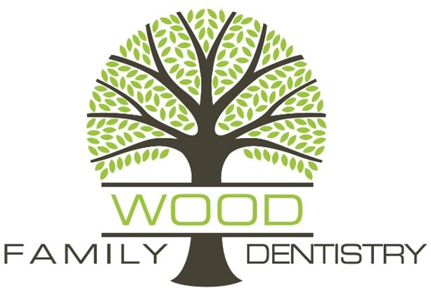

Social Media Consent

I consent to Wood Family Dentistry using photographs or videos of me, taken on the date indicated below, on their social media pages, which include, but are not limited to, Facebook and Instagram. I understand that these images and/or videos will not be used for any other commercial purposes.

_________________________________
Patient Name
_________________________________ ______________
Patient Signature Date
_________________________________ ______________
Witness Signature Date

I decline the above statement.

_________________________________
Patient Name
_________________________________ ______________
Patient Signature Date
_________________________________ ______________
Witness Signature Date

